**Selenium WebDriver:**

We don’t have Selenium web driver directly in jmeter.

Steps to Download Plugins:

Installing Plugins Manager and configuring it to JMeter

* Download WebDriver plugins for JMeter.

Download the JMeter Plugin from: “<https://jmeter-plugins.org/install/Install/>

Click on JAR file.

Go to downloads folder.

Copy path.

Go to jmeter -lib folder.

Go to ext folder.

Add plugins to ext folder.

* Click on the Available Plugins. Now, click on the Selenium/WebDriver Sampler.
* Click on Restart and the Install button. (JMeter will automatically restart).
* Click on install plugins and then click on Selenium/WebDriver Sampler.

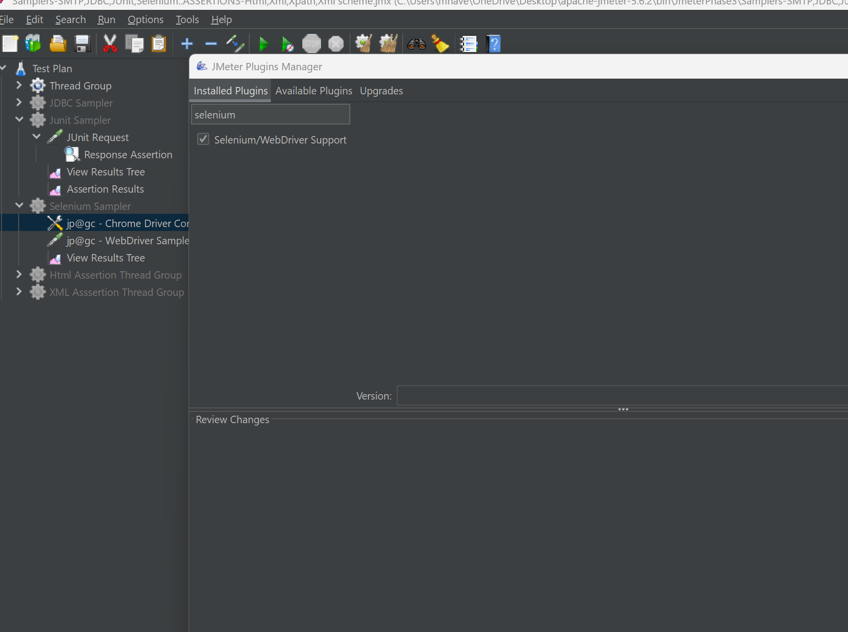

Taking The path of installed plugins chromedriver 64.

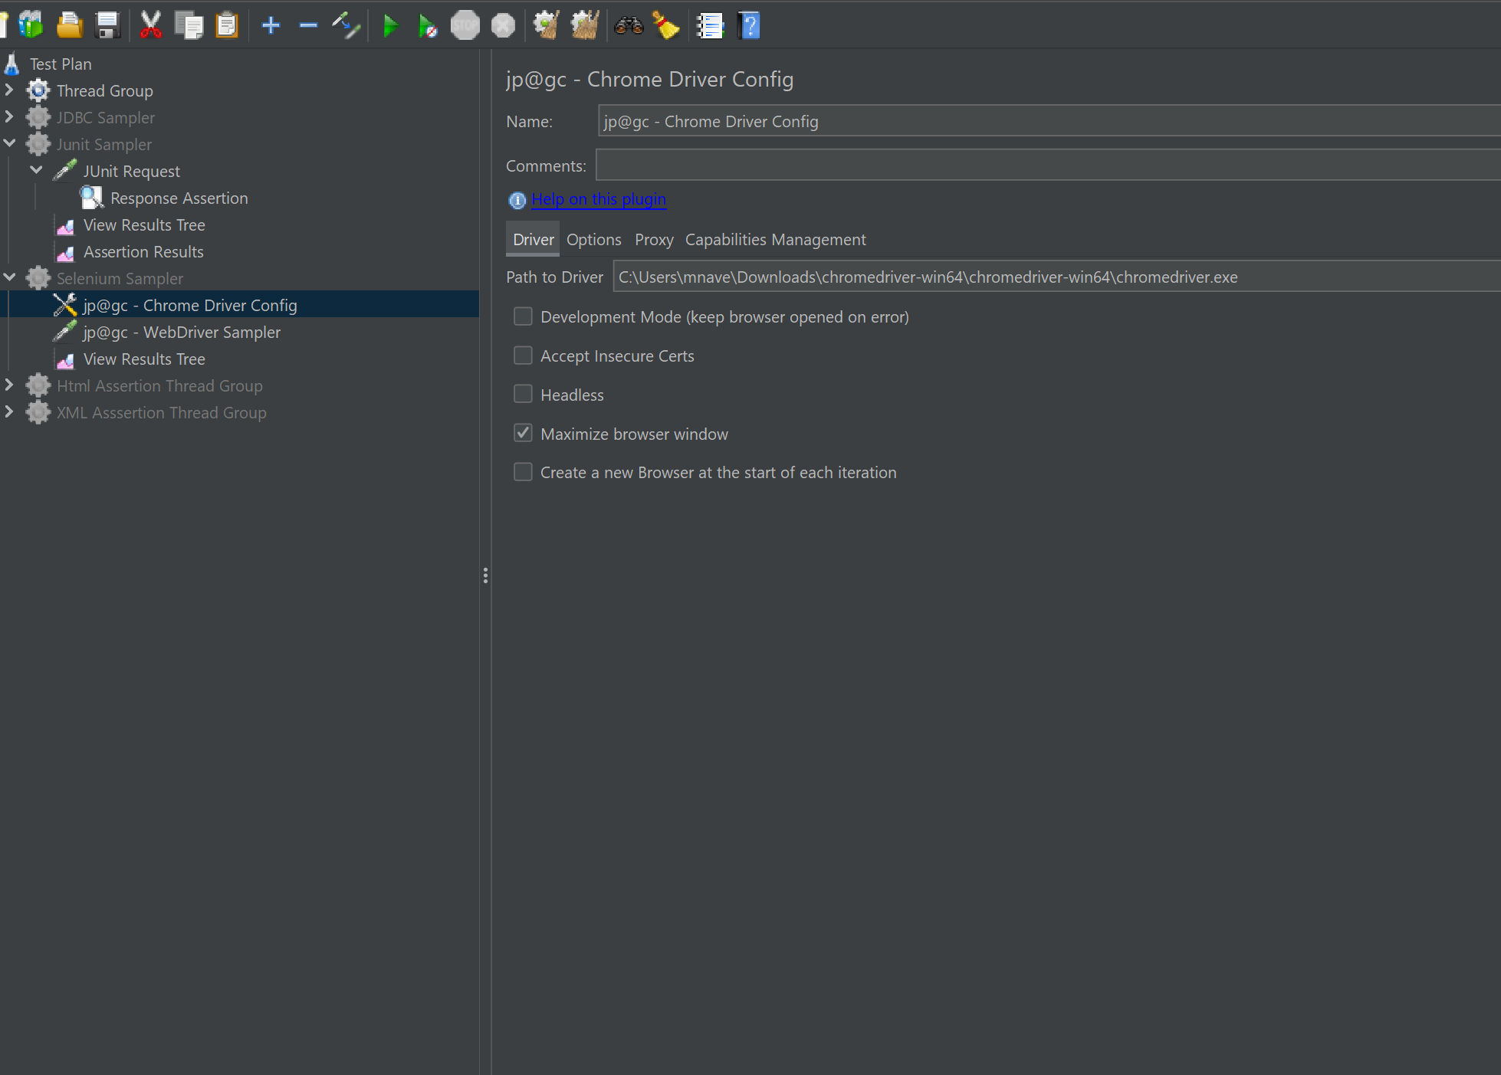

WebDriver:

We give the script of the page to be executed .

We WDS to execute each line in selenium plugins.

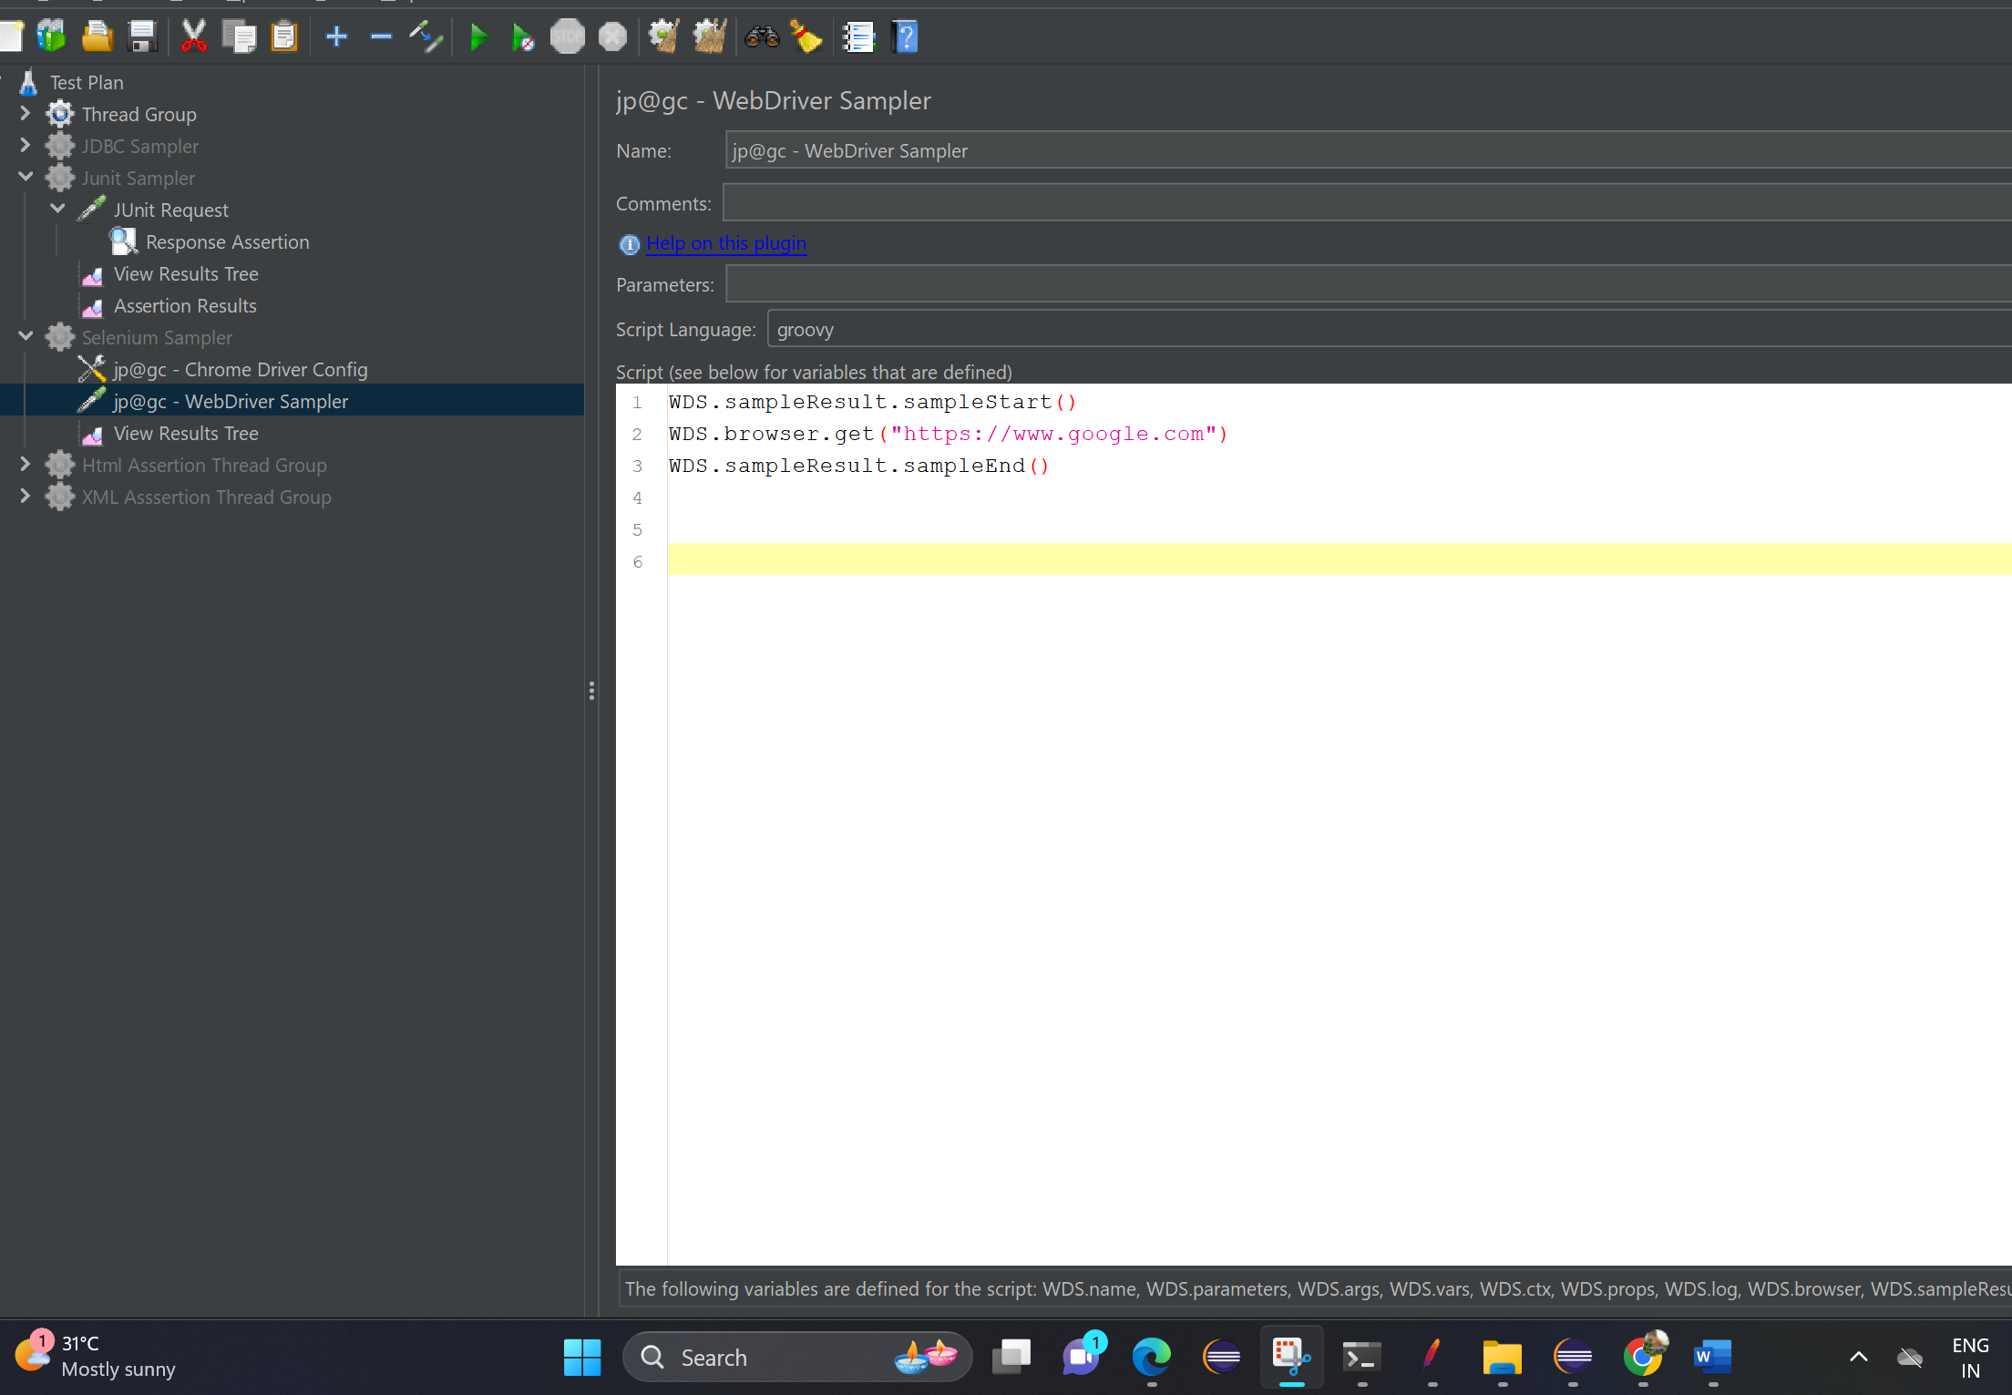

Output of page Execution:

